Knitted Sphere Tutorial
NB: you can knit these spheres in stocking stitch or garter stitch. For stocking stitch, knit odd-numbered rows and purl even-numbered rows. For garter stitch, knit every row. If you're adapting this tutorial to work in the round, work stocking stitch by knitting every round and garter stitch by knitting odd rows and purling even ones.

Select your yarn and appropriate needles. I suggest going for slightly smaller needles than recommended, because a dense fabric will contain the stuffing well.

Cast on a small number of stitches (less than 10). Let's call this starting number of stitches x.

Row 1: Increase into every stitch. You will now have twice the number of stitches than what you cast on, and will have increased by x stitches.

Row 2 and all alternate rows: Work even (no increases or decreases).

Row 3: Increase evenly along row by x stitches.

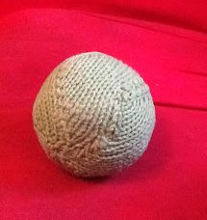
Work rows 2 and 3 until the piece is twice the width of your planned sphere. Work Row 2. If you are using a fine yarn with small needles (and therefore small stitches), work and extra 2 rows as well.

Decrease Rows

Decease Row 1: Decrease evenly along row by x stitches.

Decrease Row 2: Work even.

Repeat these two rows until you have x stitches left.

Do not cast off. Instead, cut a long tail and pass tail through remaining stitches. Pull tightly. With right sides of piece facing each other, work mattress stitch to join the sides of the piece together. Stop when you are three quarters of the way through the seam. Turn piece right side out. Stuff tightly. Finish sewing the seam closed. Hide tail inside the sphere. If it is a dog toy, give to dog. Time how many minutes it takes for him to destroy it.

Please feel free to use this tutorial to make spheres for personal use and for sale. However, do not sell this tutorial.

